SHATTERED
DIRECTOR’S VISION
PREMISE AND THEME
Set against the harrowing backdrop of Nazi-occupied Europe, this film delves into the lives of a diverse group of individuals whose fates intertwine amidst the relentless horrors of World War II. As the darkness of the Holocaust looms, the central characters—persecuted for their Jewish faith and homosexual identity—grapple with survival in a world that seeks to erase them.
Their struggle unfolds in the hidden streets and underground networks of occupied Europe, as well as the bleak confines of Flossenbürg and Auschwitz concentration camps. Each character brings a unique facet to the fight: the battles of identity, the painful choices between flight or resistance, and the desperate hope for a future beyond the brutality. With themes of love, courage, and sacrifice, this story offers an intimate portrayal of resilience and the indomitable human spirit during one of history’s darkest hours.
BRIEF SYNOPSIS
Shattered is a historical drama film noir about persecution, identity, hope and revenge set between 1942 and 1946 in The Netherlands, Germany and Poland. It focuses on the relationship between two friends, Lex a gay man and Ilse a Jewish woman. We see the devasting results that the second world war inflicts on their lives, including the destruction of their friendship.

Historical photography of anti-Semitic signage in 1940s.

PLOT
It is 1942, Lex, a lifeguard, conceals his sexuality from a hostile world while working at a local pool. On his birthday, his spirited friend Ilse—defiant and Jewish—sneaks in to visit him despite the increasing Nazi restrictions against her people. The story unfolds in 1942, as Nazi-imposed rules tighten, showing their first brutal impacts when a soldier confiscates Ilse’s bike. With most occupations barred to Jews, her brother Cor soon loses his job. During a raid their father is arrested ad mother shot. Horrified by these events Cor and Ilse go into hiding, helped by their neighbour and resistance fighter, Klaas.

By 1944, after two years in hiding, Ilse and Cor’s location is betrayed, leading to their deportation to Auschwitz. During the grueling three-day journey in a packed cattle car with no food, water, or space, Cor is wounded when soldiers fire carelessly into the crowd. As he weakens, Cor confesses he took their mother’s wedding ring to give to Erika, intensifying Ilse’s suspicions of betrayal. Heartbroken, Ilse is forced to watch as her brother succumbs to his injuries on the train.

Meanwhile, Lex’s hidden sexuality is discovered, resulting in his arrest. After a swift trial, he is sent to Flossenbürg concentration camp, where he must wear the pink triangle and becomes a frequent target of abuse.

Despite the horrors of imprisonment, both Ilse and Lex find ways to survive, forming alliances and friendships that offer moments of solace and support.

The story shifts to 1946, where Ilse and Lex reunite in the Netherlands, both carrying the scars of their concentration camp experiences. Lex hopes to leave the past behind, rejoining a family that reluctantly accepts him back into his old life. Ilse, however, is driven by grief and a thirst for justice. Fixating on Klaas for support, she learns he has moved on, now married and expecting a child. Feeling her only option is vengeance, Ilse targets Erika, whom she suspects of betrayal. On her late brother’s birthday, she arrives with a bottle of wine, intending to poison Erika. But Erika reveals that it was her mother who informed on them. At that moment, Erika’s mother enters, drawn by the sound of voices, and Ilse quickly hands her the poisoned glass. Erika, noticing the vial of poison behind the wine bottle, locks eyes with Ilse in sudden understanding.

EMPHASIS
Ilse is our main character and we follow her journey throughout the film. She is a likeable and later troubled woman. We feel her struggle during this time, from a happy person to a broken one.

CONFLICT
The Nazi Party in 1930s Germany used the Jewish people as a scapegoat for all that was wrong in society. In 1940 when the Germany army invaded The Netherlands, they began to impose their anti-Semitic laws on the population. Wearing the yellow Star of David distinguished the Jewish people from the general population. Ilse’s bike is confiscated as they were forbidden from cycling and travelling on public transport. Also, they could not work in most professions which is why Cor loses his job. This repressive regime forces them to go into hiding to escape the deportation to Poland. While the characters may not be aware of what awaits them at Auschwitz, they do have a sense that it is a forced labour camp where conditions are poor. The historical back story enhances this intense storyline.

RISKS & OBJECTIVES
Being a Jew is a risk in 1940s Europe. The Nazi considered the Jewish people to be the embodiment of all the evil in the world, whether they were old or young. Their ideology influenced a lot of ordinary people to be anti-Semitic. While some people were sympathetic and risked their own lives hiding people like Ilse and Cor. The stakes are high, once captured, the siblings are powerless to stop the fate that awaits them at Auschwitz concentration camp. When Ilse returns, her main objective has changed from surviving each day to seeking for revenge. She has little regard for her freedom. She is prepared to risk imprisonment for poisoning her friend as well as having it on her conscious.

ACTION AND CHARACTERS

Ilse, at the beginning of the film, has a very indistinct goal. Cor is her only family, and there is no mention of parents besides the reference to their father concerning the watch. We see potential tensions in Act I between Ilse and Erika. The remark made about she does not know which side she would be on if the couple broke up. Also, her friend does not appreciate the seriousness of the situation Ilse and Cor are in because they are Jewish. When Cor confesses to telling Erika their location, it plants a seed of doubt in her friend’s loyalty. On the cattle car, she searches her mind to find who could have betrayed them. Once Cor confesses to visiting Erika, it convinces her she is their betrayer.

Losing Cor, whom she was close too has a devastating impact on her. She experienced horrendous depravations in the concentration camp. To gain a sense of power and control, she feels she needs to get revenge on her betrayer. Choosing to visit Erika on Cor’s birthday is calculating move, relying on this date to give emotional weight to her vengeance.
ILSE JENSEN
The main character is happy-go-lucky and jolly. Ilse is Jewish and very close to her brother, Cor, because he is the only family member she has. Her brother's girlfriend Erika is her best friend and they are like sisters. Ilse begins to doubt her friend's loyalty, however. On the train, she becomes angry at her brother for giving away their father's watch. Ilse is cold to him and begins to brood on how Erika would have sold the watch straight away and be living well at their expense. When her brother dies, she feels lost and angry. As a result of her brother's death and the horrors of Auschwitz, Ilse becomes fixated with who betrayed them. She returns in 1946 a broken woman, she has her hair shaved, on her wrist, she has a tattoo showing her prisoner number. Ilse is determined to get revenge, believing Erika betrayed them and does not care about the consequences. Fixated on vengeance, she cannot move on until she gets retribution
.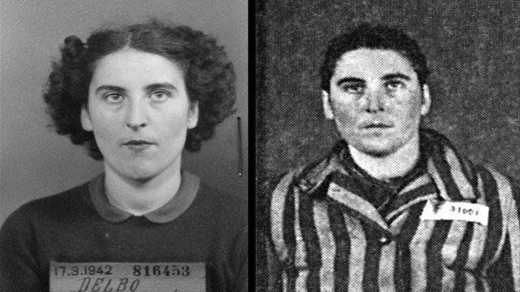
Jewish Holocaust Survivor Before and After The War
MOTIVATION, OBJECTIVE & OBSTACLES: 1942 – She takes life as she finds it has no real goals. 1944 – To survive the horror of the concentration camp. 1946 – Ilse cannot move on, haunted by the events of the past two years. She has to get revenge. To get Erika to drink poison Ilse brings wine to toast Cor’s birthday. She risks discovery, killing the person who gave away the sibling’s hiding place. However, she is determined to get the person responsible no matter what
.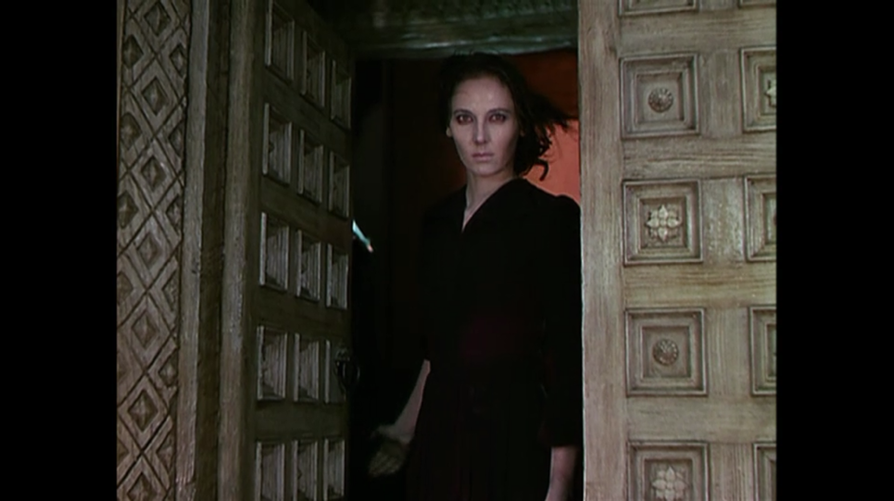
Black Narcissus (Powell/Pressburger 1947)
COR JENSEN
Cor Jensen is older than his sister by three years. He is a kind, protective person who only ever sees the good in people. Cor puts his and Ilse's life at risk by going to see Erika. Although his actions are noble, to see the woman he loves and help her financially, he is naive and reckless. His visit is the catalyst for Erika's mother to inform on them overhearing their hiding place. He never doubts Erika's love and loyalty for him, nor could not conceive the idea that Mrs Baaker would ever betray him. Even though he knew she did not approve of their relationship, he believes it is because she does not feel he is good enough. He does not suspect it is because she hates Jews.
MOTIVATION, OBJECTIVE & OBSTACLES: 1942 – to marry Erika. However, as a Jewish man who finds himself without an income and suffering Nazi persecution, his ambition is getting further away each day. He desperately misses Erika and his objective is to help her. He risks arrest trying to get to her. Separated from the woman he loves, surviving from day to day has left him living at his wit's end. Cabin fever sets in at the hiding place and he takes a risk even though he could be caught or followed. 1944 – He wants to protect the people his sister and is scared of what awaits them at the end of the line. When the guards fire into the train carriage injuring and killing people, he realises that death is the only outcome. He is scared and devastated by his bullet wound. In any other circumstance, his injury is treatable, but he now knows the Nazis will kill him if he does not die before he arrives.
ERIKA BAAKER
Erika Baaker is working-class, unlike Cor and Ilse, who are middle class. She is the same age as Ilse. However, she does not understand the position of privilege she has being non-Jewish/Christian. She seems immature and gullible, thinking the people of Holland will stand against the Nazis and stop the persecution of the Jews. When her friends disappear, she worries for them but relieved when Cor appears to say that they are in hiding. She is angry with her mother for betraying her friends. Poverty is all that keeps her at home. She is shocked but happy at Ilse's return, yet she is uncomfortable too. Her mother is asleep in bed and she is worried she will wake; however, she must tell her friend the truth.
MOTIVATION, OBJECTIVE & OBSTACLES: 1942 – To marry Cor. She is not the sort of person to keep up with current affairs, especially the war and politics.1944 – To survive the bombings and food shortages of the war. She misses Cor and Ilse desperately and spends most of the time lost in thought, worrying if her friends are alive or dead. 1946 – To leave her mother and Holland. She is shocked when she hears what her mother did and disgusted, even more, when news of the atrocities in Auschwitz reach her ears.
MRS BAAKER
Mrs Baaker is a housewife, common, rough and ignorant. She cares little for anyone else but herself. She believes in the Nazi propaganda against Jews and did not want her daughter to associate with them.
MOTIVATION, OBJECTIVE & OBSTACLES: 1942 – She hopes her daughter will break up with Cor. 1944 – She considers herself a good citizen by turning in two Jews. She believes now that Jewish people are vermin, being swayed by the propaganda. Even though she knows her daughter will be heartbroken, her objective is to turn Cor in. She is outraged that he came to their house like he used to before the Nazi invasion. 1946 – Now the war is over she can forget about the unpleasant wartime years. She is frustrated with herself for inadvertently admitting she betrayed the siblings, yet, she feels there is no consequence to her actions. She believes her daughter will forgive her and move on. She is shocked at Ilse's arrival and disgusted at a Jew in her house. She is not sorry for what she did. However, in astonishment at seeing Ilse, and in her half-sleeping state, she is more compliant than she would be fully awake. Therefore, to avoid confrontation, Mrs Baaker accepts the drink offered to her.

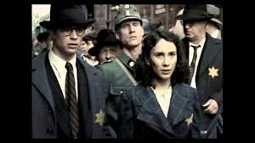
The Last Train To Auschwitz (Vilsmaier/Vavrova 2006, above and below)
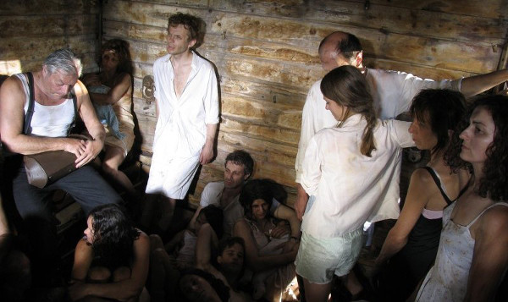
VISUAL STYLE
Shattered will be black and white. Research into film noir and German expressionism has helped with regards to the lighting, plus the use of camera placement and movement. It has involved watching films that are relevant either for their historical context such as, The Last Train To Auschwitz (Vilsmair & Vavrova, 2006) or their style, i.e. Notorious (Hitchcock, 1946). When lighting the actor’s faces in the cattle car scene, we can imply prison and captivity within the dark cattle car and apartment. There are strong, emotional high points and the research conducted has helped with the creative choices made, to convey the critical moments and concepts in the film.
PRE-PRODUCTION
CASTING
In 1942, the characters ae happy, healthy and full of life. By contrast between in 1944, Erika is unchanged, but the siblings have altered significantly. In the cattle car they are bedraggled, their hair, limp, greasy, their eyes hollow and full of fear. By 1946 Ilse, her short hair and drawn face. Her features and deportment will show a woman driven by dark and powerful emotions. When casting for Ilse, an actor is needed who can transform from a happy-go-lucky person to a murderer. The role will require the actor to have short hair.
Erika is also affected by 1946, with the discovery of her mother’s betrayal she is wiser, guarded and mistrustful. So, it requires an actor who can give a subtle performance.
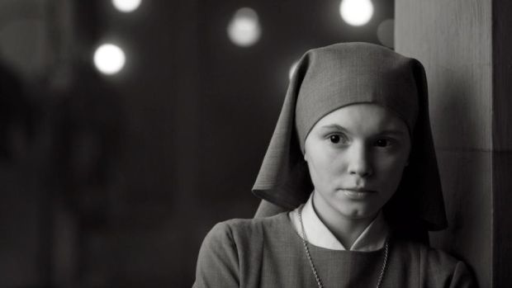
Ida (Pawilikowski, 2013)
LOCATIONS
- Canal

To set the scene that we are in The Netherlands, we need to get exterior shots of the characters cycling along a canal.

Update – After the location recce, we have decided to use two separate parts of the canal for Scene 1 and 2 to give a sense of a larger the world.

- Steam Train & Cattle Car

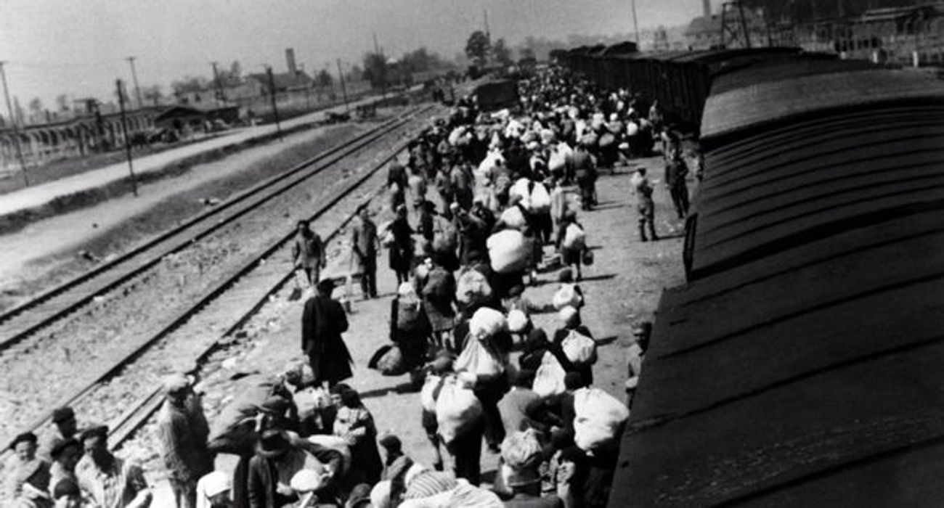

The audience will see shots of steam rising, bumpers meeting, a steam train arriving in at a train station with Nazi flags flying. On the platform, people wait with their luggage looking worried. To give a sense that if the audience could walk out of the train station, they would be walking in 1944, Holland. The signs of Nazi occupation would be everywhere.
Keighley Worth Valley Railway has a steam train, platform and a cattle car on the sidings used for storage at the moment.
Update – Unfortunately we have had to scale down and scrap most of this idea. The main reason is due mainly due to budget restrictions. We cannot get enough background actors to the steam railway. Once there, we would not only have to feed them and cover their expenses; wardrobe is an additional issue. To book out vintage clothing from the costume hire company, we need to request them four weeks in advance, which is impossible with unpaid background actors. As well as the cost to hire costumes, we would not be able to sew on the Star of David. In addition, the Operations Manager has not been very helpful as we are a student production. The cattle car exterior shots would require us to pay for the removal and storage of the equipment. The producers decided is sadly not within our means to pay for these requirements for possibly two minutes maximum of world-building in the film. We have decided that we could spend the money elsewhere. As Cor initially sustains a head injury from a soldier while climbing into the cattle car, a script revision was required. Now Cor will be injured by a bullet fired by a soldier outside the train.

Middleton Railway has agreed to let us film there for free and cooperative. We will be filming more abstract shots of the train moving over up the tracks from the rear, the steam and the bumpers.

3) Interior of Cattle Car
We will be building the interior of the cattle car at Prime Studios in Leeds. We were considering at one point filming on location, but due to problems with the railway, it will not be possible. It is preferable to shoot this scene in the studio as it would be difficult to control the light on location. As there is little natural light coming from the small grills, it is a difficult scene to light. The ability to move the set means we can get the shots we require.
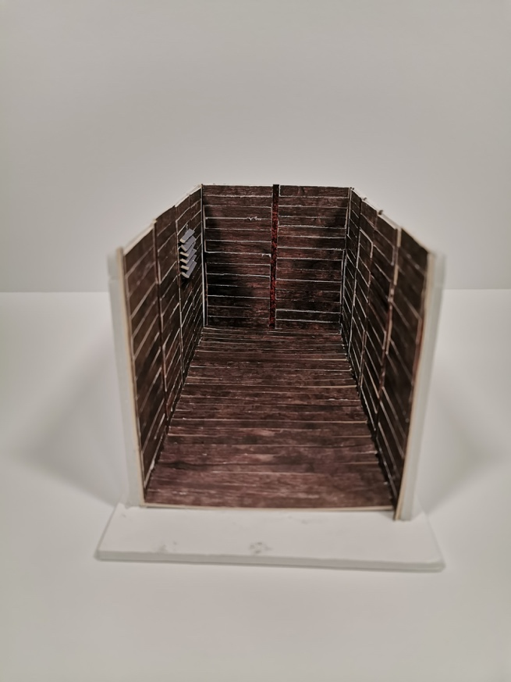
Scale 3D model of interior cattle car designed by our Ella Linden, Production Designer
- Interior Staircase

The staircase shot will help set the scene for Ilse’s return for revenge. We will be filming in the location of our test shoot, which is a Victorian building suitable for the time.

The Spiral Staircase (Siodmak, 1946)

- Interior Sitting Room

The audience will see this sitting room as it is around 1944, well decorated and furnished. We will then see it again in 1946, most of the furniture has gone, and it is looking shabbier. The war has taken its toll on the apartment too.

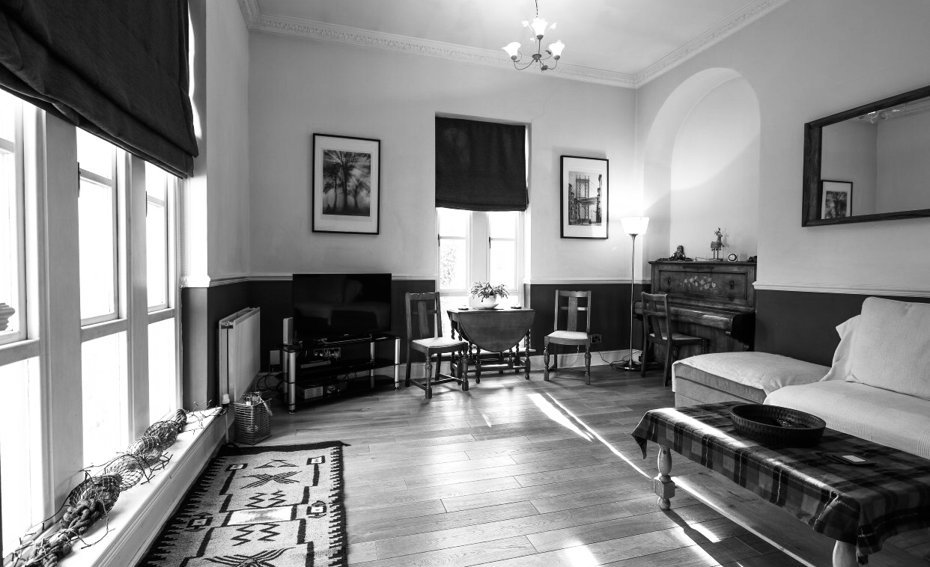
Location

Update: We have found a suitable location, a Victorian building. We have confirmed with Laura Torenbeek that this looks authentically Dutch.

FUNDING

CINEMATOGRAPHY IDEAS AND MOODBOARD
The film will be in aspect ratio 16.9.

Holding regular meetings with the Director of Photography, we go over the shots and storyboard, planning the best way to approach the scenes.

We have looked at cinematographers such as John Alton, Robert Krasker, Davis Boulton and Russell Metty.
Research has been conducted reading books and looking at website resources such as. No Film School article on Film Noir: https://nofilmschool.com/2017/02/watch-film-noir-and-case-black-and-white In addition a list of films was to watch, either for their historical context of cinematography.
Act I
Canal Scene I want the scene to be brightly lit and to give the impression of a sunny day. Obviously, we are at the mercy of the weather, however if we get a bright sunny day it will reflect the initial light, carefree nature of the characters. We have been looking at bright – blown out skies which contrast well with dark colours.
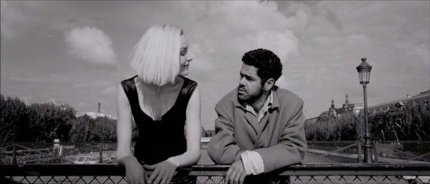
Both images above - Angel A (Luc Besson, 2005)
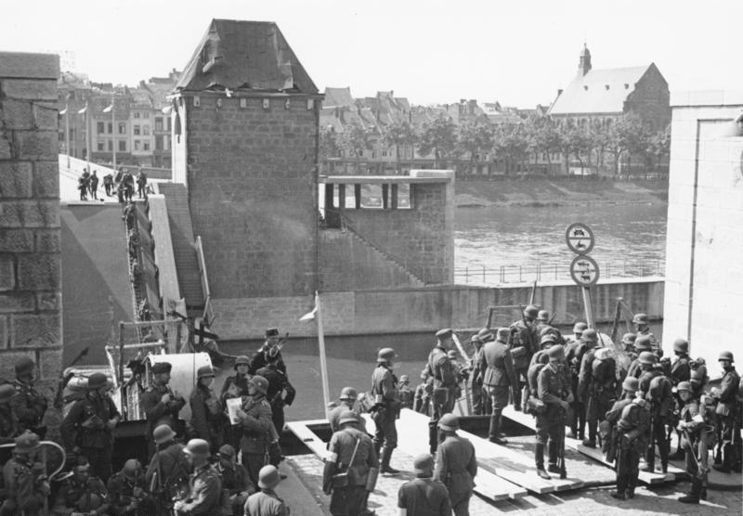
Photo taken in The Netherlands, 1940
Act II
The scene needs to be dark as the only available light is from the grill.
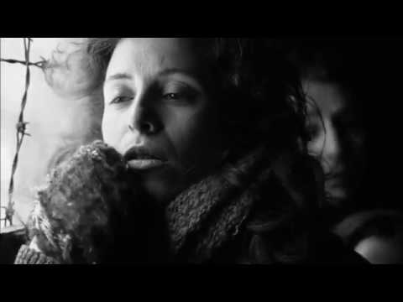

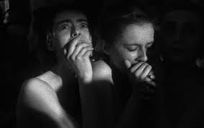
Both Photos - Schindler’s List (Spielberg, 1994)
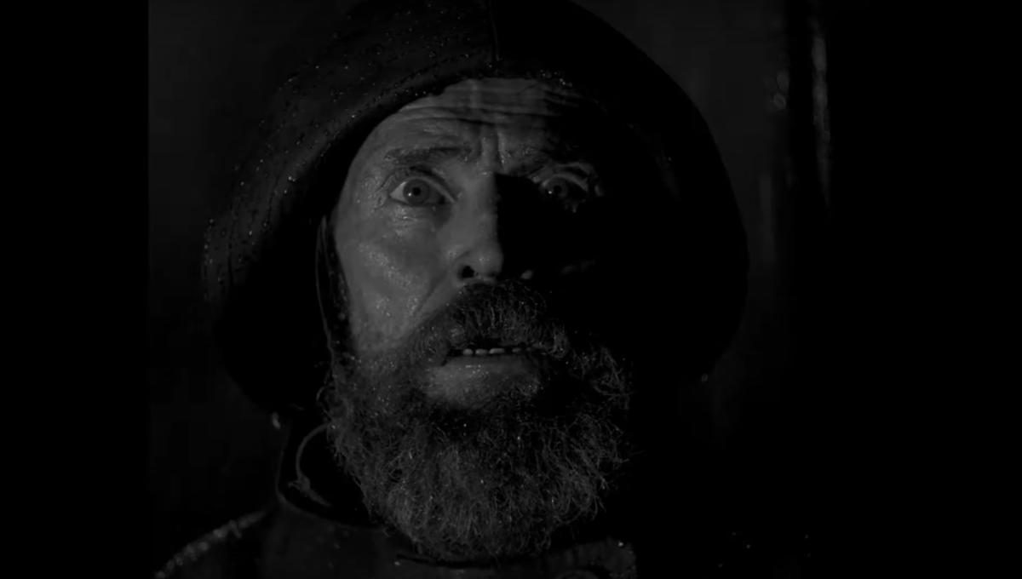
The Lighthouse (Robert Eggers, 2019)
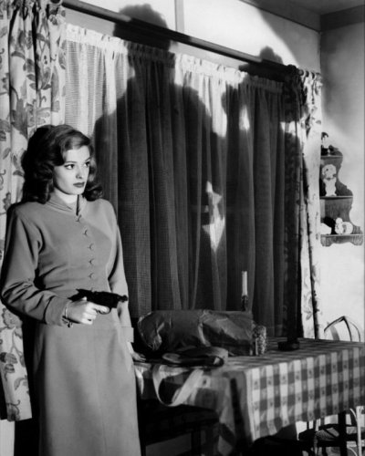
Out Of The Past (Tourneur, 1947)
As people get off the cattle car more of Ilse and her brother will be revealed.

ACT III
Staircase scene – While this can be seen as a desultory scene, just a transitionary corridor into another scene, it is more than that. It is setting the tone. Ominous shadows walking up the stairs, foreshadow what is to come. When Ilse returns to take her revenge, we need lots of darkness to emphasise the dark state of mind the character.

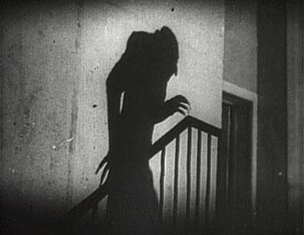
Nosferatu (Murnau, 1922)

Inside the apartment, Erika to be well lit but Ilse at the beginning of the scene to be in shadows. We will have to do test shoots to work out how to achieve this.
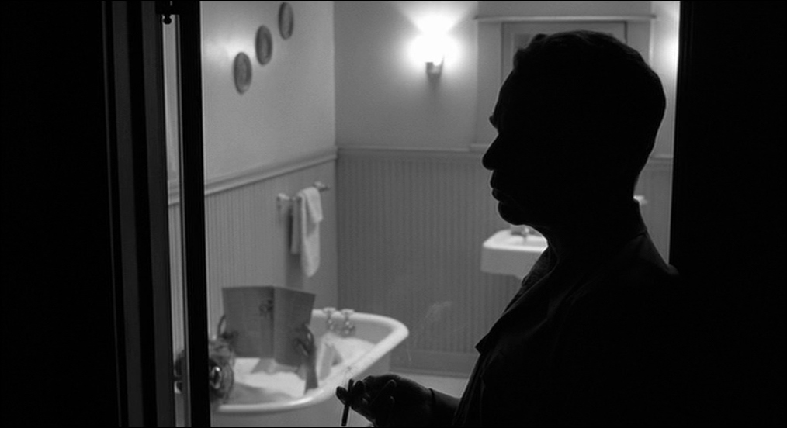
The Man Who Wasn’t There (Coen Brothers, 2001)
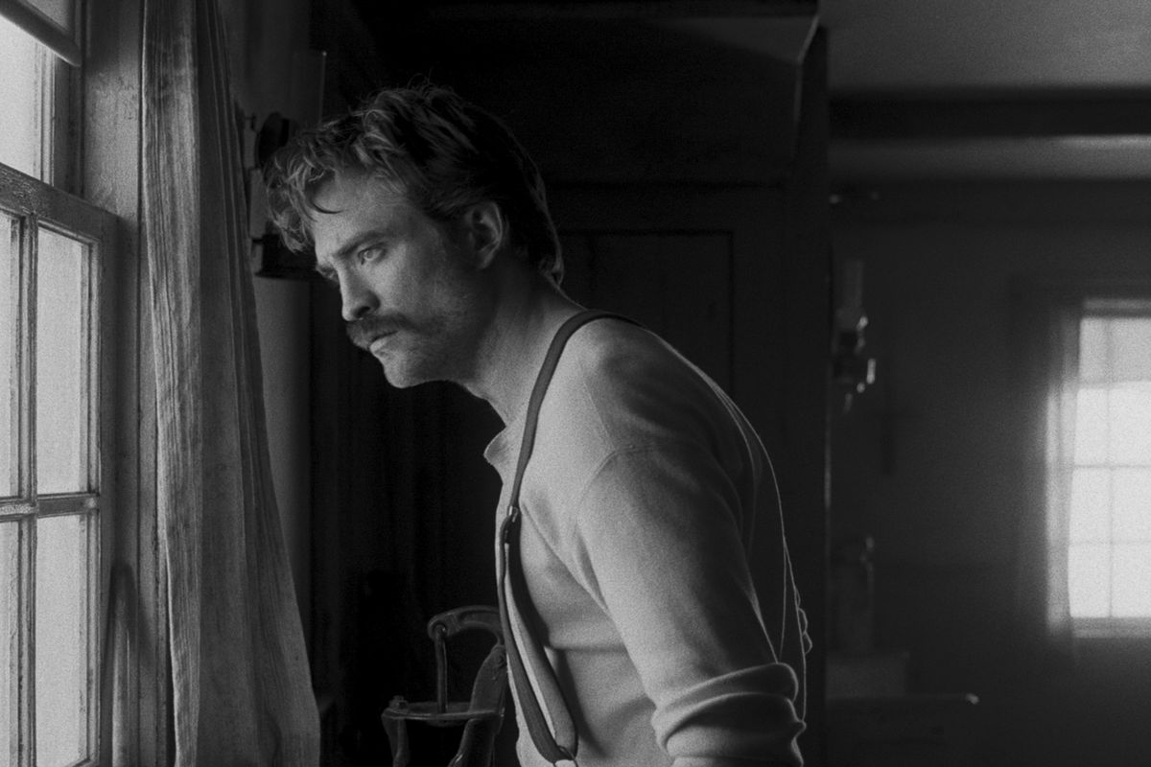
Above and Below - The Lighthouse (Robert Eggers, 2019)
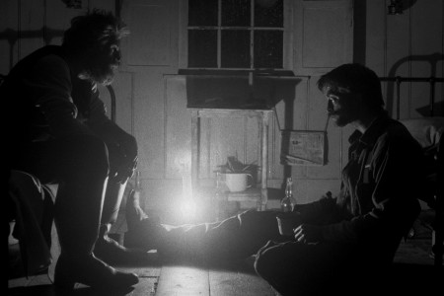
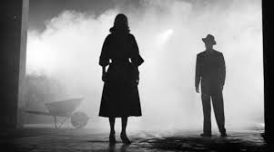
The Big Combo (Lewis, 1955) & The Night Of The Hunter (Laughton, 1955)

PRODUCTION DESIGN MOOD BOARD
ACT I
Ilse, Erika and Cor will look neat, tidy and healthy. Women & men’s fashion 1940s.
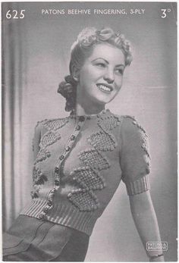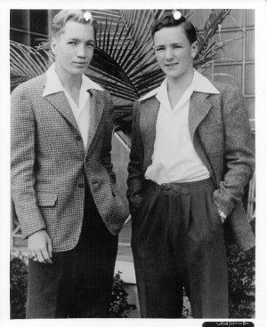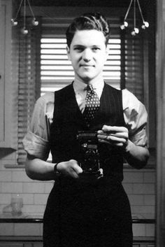

Clothing of Soldiers
Nazi uniform of the time period
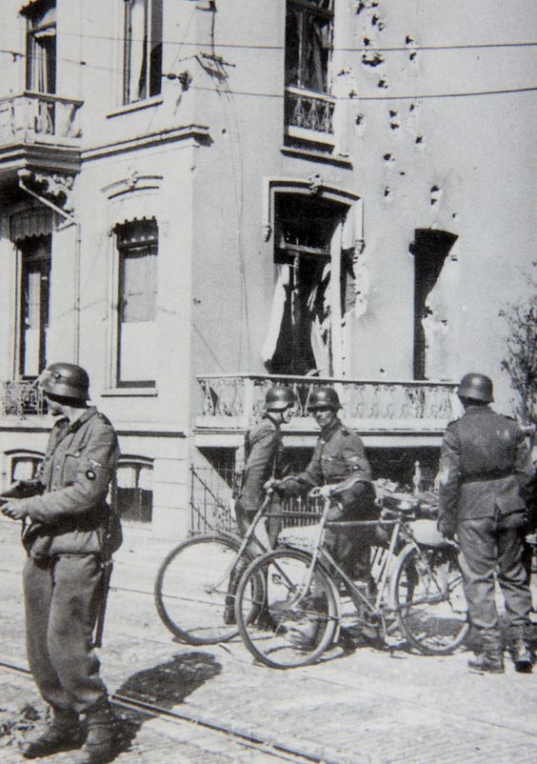
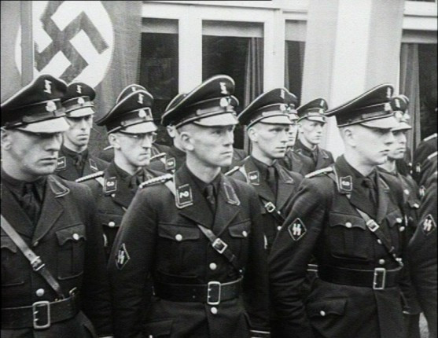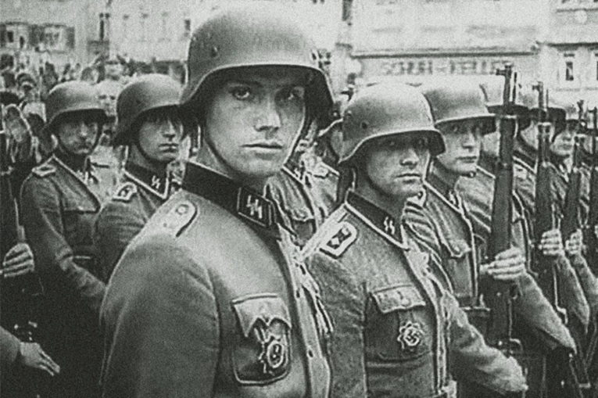
Dutch Waffen SS
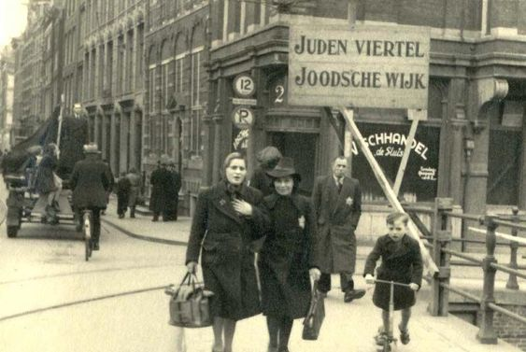
Vintage Signage Against Jews

ACT II – CATTLE CAR
The people will be dishevelled on day one, each day looking pale, sweaty and drawn Dressed in light clothing so the dark clothing does not absorb light in dark interior of space.
Main Appearance: Ill
Cracked lips
Dead bodies
Men unshaven
Greasy skin
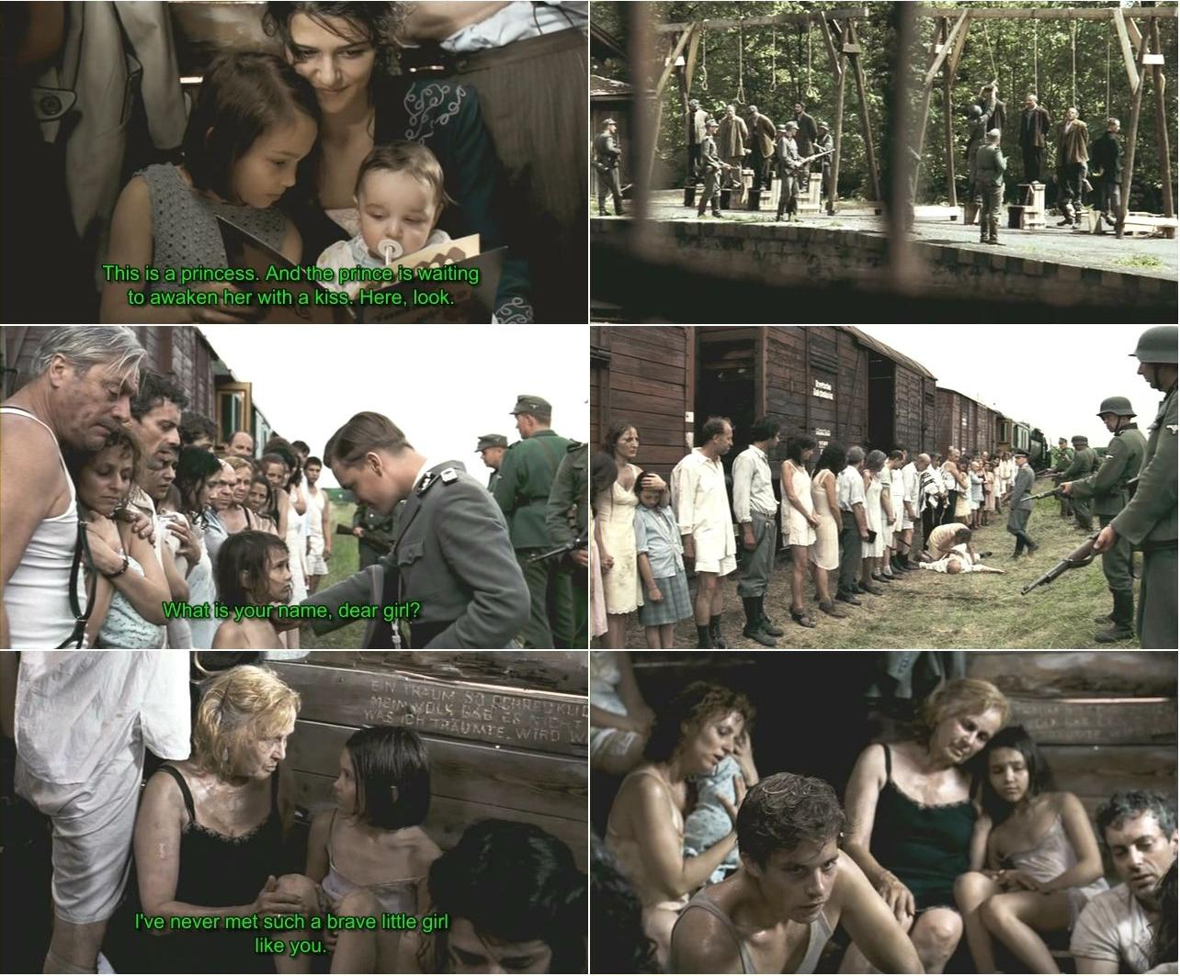
The Last Train To Auschwitz (Vilsmaier/Vavrova 2006)

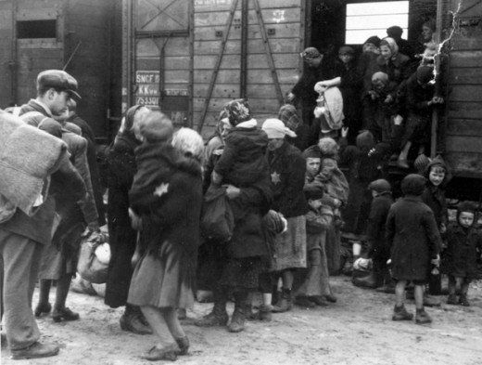
Vintage photos of bedraggled, worn out, tired. Scruffy clothes, dirty, carry bags of possessions.
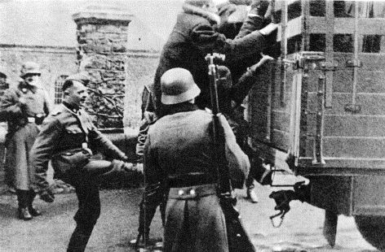
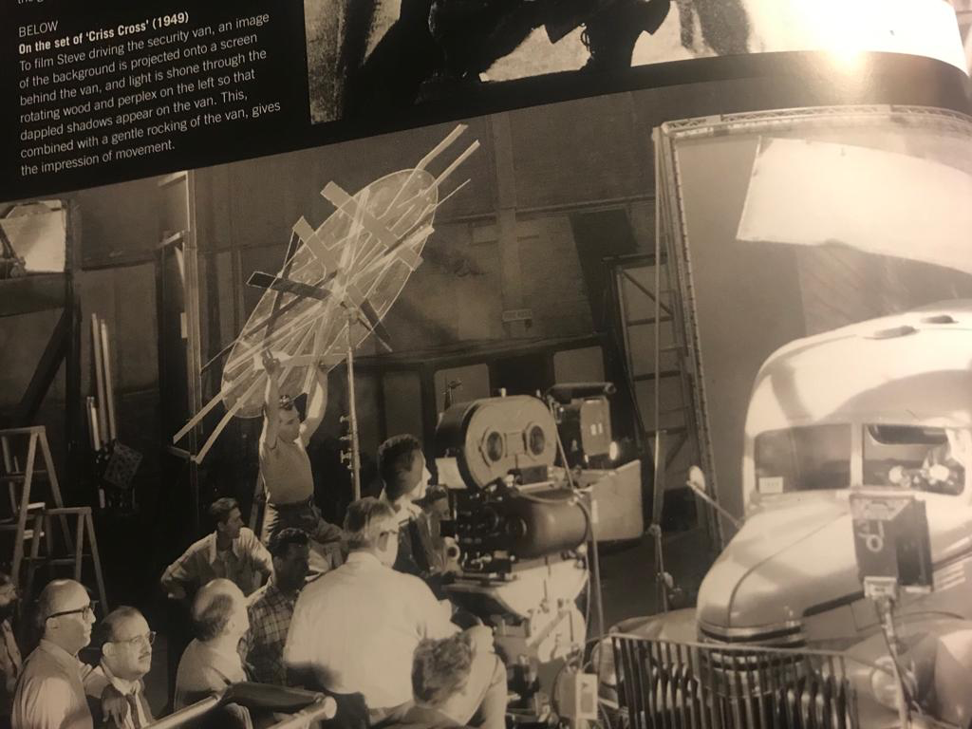
This is a BTS still from Criss Criss(1949). They used a rotating wheel with wood nailed to it to give the illusion of movement. Use twigs, branches etc. waved in front of the light.

Photos of Cattle Car taken at Auschwitz in 2017
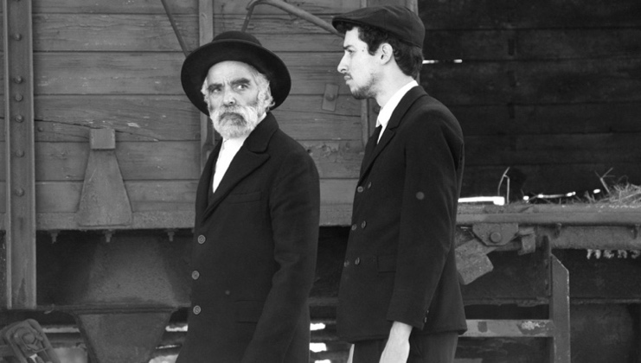
1945 (Szilagyi, 2017)
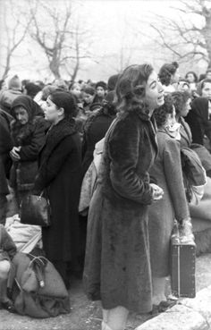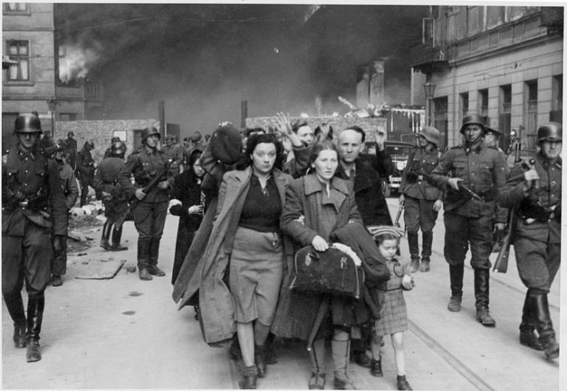
Above - Vintage Photos of People at Train Station
Below -The Pianist (Polanski, 2002)
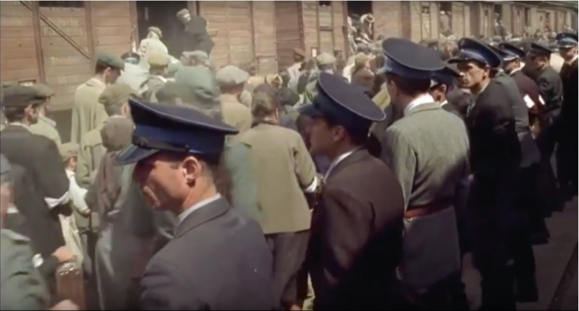

ACT III – ILSE REVENGE
PRODUCTION DESIGN MOOD BOARD
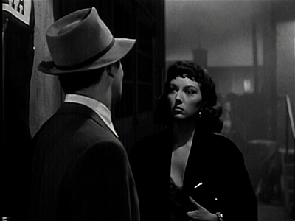
The Big Combo (Lewis, 1955)
When Ilse returns for her revenge, she is dressed in black with a hint of white, it indicates she still has some goodness within. Erika will be in worn clothing.
The staircase would be drab after the war, not elegant or elaborately decorated as she is working class. Erika does not have a great deal of money. Her apartment after the war would be bare also having sold most of her possessions during the war to survive.
Vintage lettering for the poison bottle and signs:
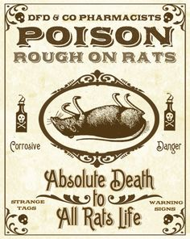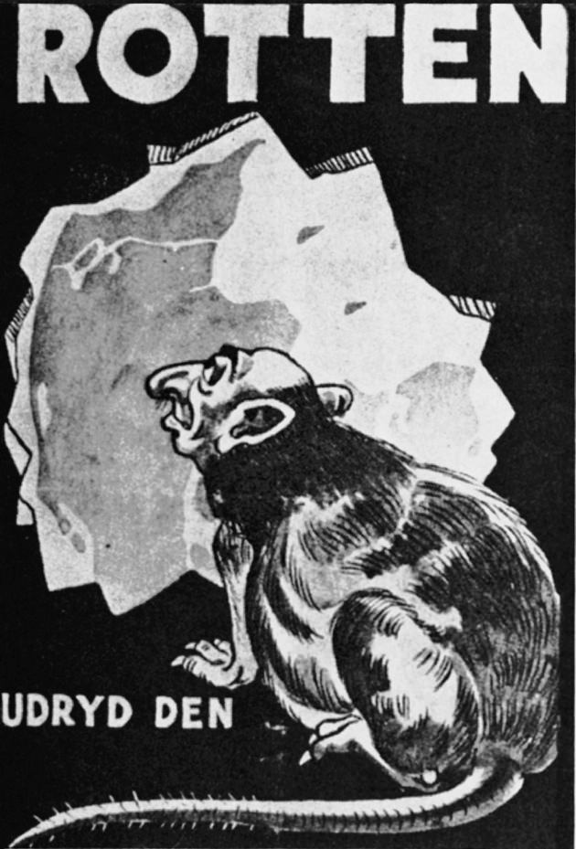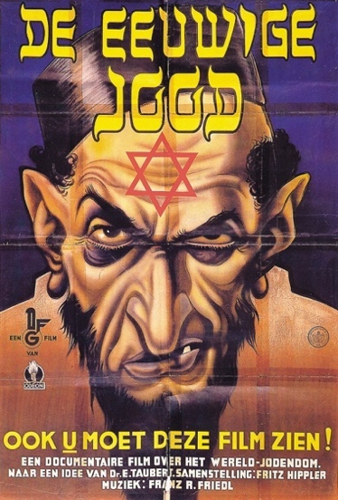
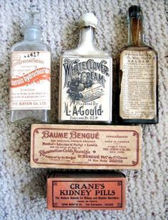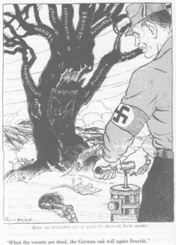
Jews were often compared to rats and vermin. Poison bottle needs to have similar imagery.
Interior of Erika’s Apartment. Vintage Dutch wartime apartment.
: 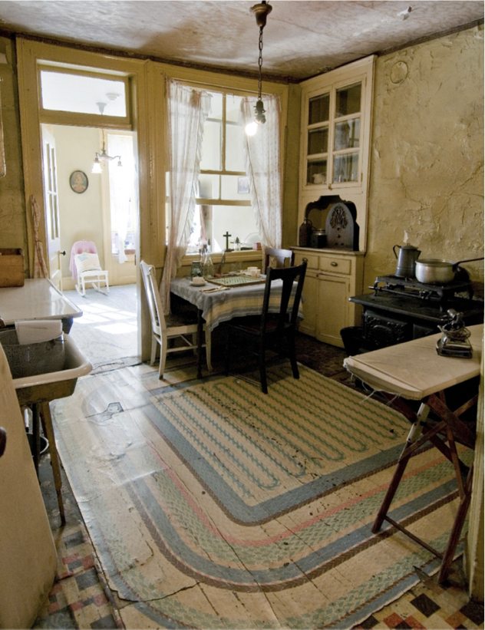
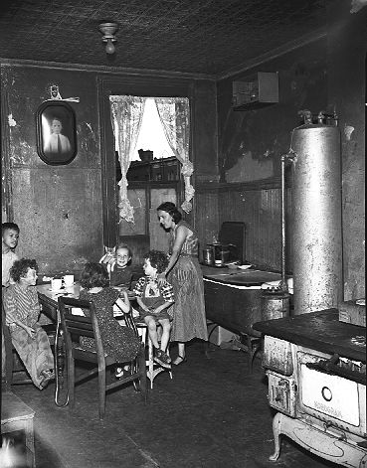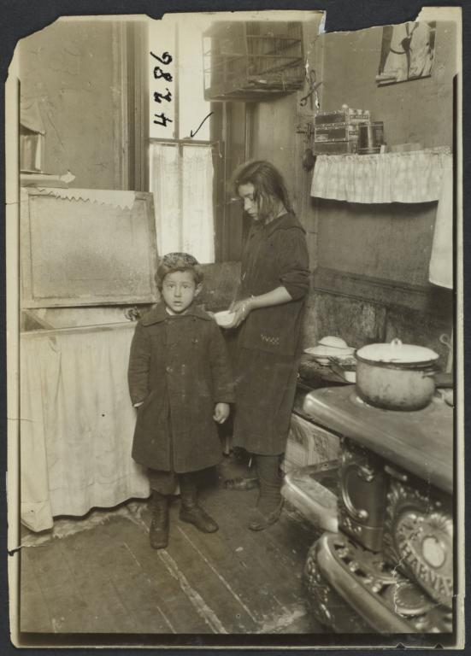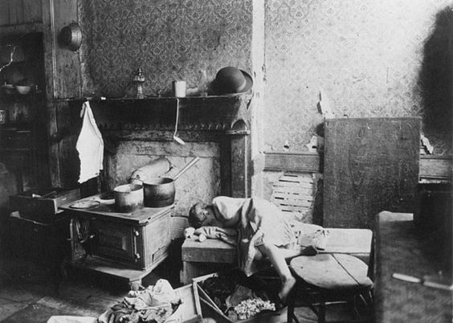
Vintage photos of interiors in The Netherlands during that tieme period.

ACT III – ILSE’S RETURNS FOR REVENGE – STAIRCASE AND APPARTMENT Staircase
We will need to build the interior of the cattle car as I imagine it would be extremely difficult to film in a real one.
Glass door to Eirka’s Flat
Depending on the location we find I would like the apartment to have a glass door. We would see Ilse ascend the staircase, as she approaches the door from the inside. She would be a dark shadow against the glass door.

Above and Below – Stock Photos


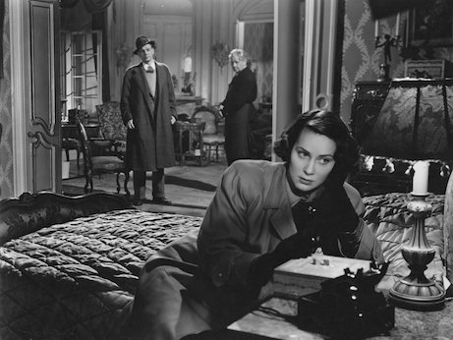
Third Man (Reed, 1949)

EDITING

The film will begin with abstract shots of the train moving over the tracks at the beginning of the film, foreshadowing a haunting story. During Scene 3 where Cor talks about his visit to Erika, we will edit in another Scene 4, which is Cor’s memory of the visit.

Ilse is trapped mentally in that cattle car even in 1946. We will still see brief shots of the train tracks during Act III and at the end of the film after she poisons Mrs Baaker.

It will need lots of preparation in preproduction to ensure we tell the story getting in all the emotional high points and drama while keeping to the running time 15 minutes.

During test shoots we have been experimenting with the colour grade to get the right tone. The blown out whites and intense blacks are a favourite LUT.

SOUND AND MUSIC

The film will have the sound of the train tracks coming in and out at the beginning of the film, as the music starts and fade out at the end. Sound will be instrumental in telling the story.
Act I – We hear a train whistle at the end of act I where the characters are by the canal. The scene will transition and we will see a steam train.
Act II – We will hear the sounds of train movement, soldiers, people crying, dogs, shots fired as well as screaming will play an essential part in telling the story.
Act III – The room will be quiet and echoey to reflect the bareness of this once well-furnished apartment. These sounds will also be edited in during the final revenge scene showing that Ilse has PTSD.
Using musical underscore, it will give the audience a sense of fear and tension. The character Ilse will need an original score composing to define the character and the emotion of the film.
MAIN THEME AND AUDIENCE
Trip to Auschwitz (Moorhead, 2017)
We think that we cannot repeat the mistakes of the past, as we have knowledge and facts at our fingertips. In the previous decade, fascism has risen again and the persecution of multiple groups of people as easy scapegoats for hate. By retelling a story of Nazi oppression, I hope to keep this history alive. To make the audience aware of the horrors of slipping down the path of intolerance and bigotry. The central theme is that evil does not die, and we need to be vigilant against it. We are at the beginning of a new decade, and I hope that we can find a way to live and work together.
The main audience for this film are people who like historical topics and second world war films. Aimed at adults who can appreciate the motivation of the characters and the circumstances the characters are in.

Overview of Shattered
We see an abstract shot of train tracks taken from the back of a moving train and hear the sound of the locomotion. Music fades in. TITLES and OPENING CREDITS as well as date and location: THE NETHERLANDS – 1942. The music turns subtly menacing.

1942 – ACT I

1 EXT. CANAL
Ilse and Erika set off cycling along the canal talking. A ¾ length-shot that tracks into a mid-shot.
Shot of Nazi on bridge
Camera follows soldier’s Nazi armband as he holds up hand and shouts at Ilse
Ilse walks past upset.

2. EXT. CANAL LATER 1942
Ilse sits while Erika stands waiting for Cor by canal.
Two shot of Erika and Cor.
Ilse stands up and Cor walks into frame.
Single of Erika

1944 – ACT II

3. INT. CATTLE CAR
Abstract shot of steam train.
Camera sees Ilse and Cor in a packed cattle car..
Cor confesses to visiting Erika, while scene 4 is edited over this section.
Dirty two shot of Ilse talking to Cor
Reverse of two shot
Dolly pushing into to Ilse and Cor
Tracking shot of Ilse and Cor

4. INT. SITTING ROOM – ERIKA’S APARTMENT
Cor enters apartment, three shot. Focus Cor and Erika, Mrs Baaker in background. Pull focus to her a he leaves.
Close up of watch being exchanged and camera tilts down.

5. INT. CATTLE CAR
Train jolts to stop
A bucket falls over
A person falls as bullets are fired.
Two shot of Ilse and Cor, camera tilts down to reveal his injury.

6 INT. SITTING ROOM ERIKA’S
Static single of Mrs Baaker sitting in her chair.
Dolly in on Erika.

7. INT. CATTLE CAR. ARRIVAL AT AUSCHWITZ. 1944.
Shot of people leaving car
CU of Ilse which pulls out to reveal Cor is dead..
1946 – ACT III

8. EXT. STAIRWELL ERIKA’S APARTMENT
Close up of a hand pulling a bottle of poison out of pocket and replacing it.
Shadow ascending stairs.

9.. INT. ERIKA’S APARTMENT
Wide of Erika hearing knocking at the door and rising to open door.
Dolly to shadowy figure behind door.

10.EXT. ERIKA’S APARTMENT
Single of Erika – medium close up

11.INT. ERIKA’S APARTMENT
Close up of Ilse’s face.

12. INT. ERIKA’S APARTMENT
Wide of Ilse in apartment. Erika brings in two glasses. Tilt, pan and pull focus.
Dolly shot following glass being carried to Erika
Dirty two shot of Ilse
Reverse shot of Erika
Single of Mrs Baaker entering
Two shot panning up to Ilse looking over at Erika.
MOVIES TO WATCH

- The Last Train To Auschwitz (Joseph Vilsmaier, Dana Vávrová, 2006)
Available to watch for free on YouTube, but it is low quality: https://youtu.be/Xm25vh4jjUY
- The Pianist (Roman Polanski, 2003
Trailer: https://youtu.be/BFwGqLa_oAo
- Schindler’s List (Steven Spielberg, 1994)
Trailer: https://youtu.be/gG22XNhtnoY
- Ida (Pawel Pawlikowski, 2015)
Trailer: https://youtu.be/_JIXxo8qUn0
- Cold War (Pawel Pawlikowski, 2018)
https://youtu.be/8ImvkXgGVWw
- Nosferatu (FW Murnau, 1922)
Available to watch for free on YouTube: https://youtu.be/FC6jFoYm3xs
- Out Of The Past (Jacques Tourneur, 1947)
Trailer: https://youtu.be/saurMhQHblc
- The Third Man (Carol Reed, 1949)
Trailer: https://youtu.be/r9yyDEDGlr0


Trip to Auschwitz (Moorhead, 2017)
PERSONAL NOTE - WHAT ATTRACED ME TO THE SCRIPT
Shattered is a mature and gripping story. It resonated with me for two reasons. Firstly, I visited Auschwitz a few years ago. I thought I knew about the concentration camp from watching films and documentaries. However, being there first-hand, seeing and hearing about the treatment of the prisoners was horrifying. It affected me the scale of industrial torture and murder.
Secondly, as a child, I had to go into hiding myself. My family were forced to flee our home in Belfast in the middle of the night. Loyalist paramilitaries tried to break into our house to kill us simply because we were Catholics. That night was my parent's wedding anniversary, and many of their friends were there celebrating with them. They threw bricks through our living room window and retreated when they heard multiple voices inside. However not before they threatened to return the following night. My parents dashed upstairs, carrying myself and my sister out to a waiting car. We were driven to a friend's house and spent the next few months there living in hiding.
This memory from my childhood was triggered when I read the script. I understand what it is like to live in fear and to go into hiding, even though it was only for a few months. We had no possessions having left everything behind, we were bedraggled and the worst for wear. In that situation, a person exists from one moment to the next, terrified, worrying about what will happen. This unique perspective means that I am the right director for this film to work with the actors to create a believable performance. These experiences have given me insight into how the characters would think and feel.

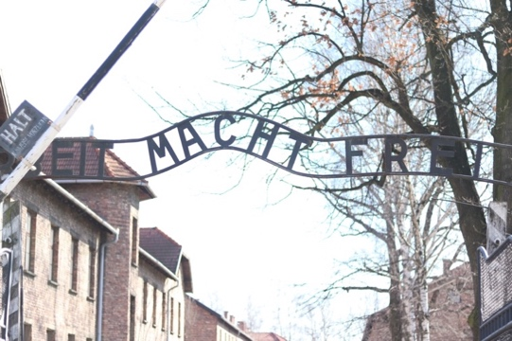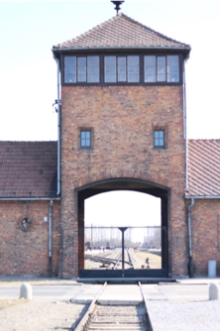
Trip to Auschwitz (Moorhead, 2017)

- Setting in the Netherlands, 1942: The story unfolds during World War II when the Netherlands was under Nazi occupation. The Dutch faced oppressive Nazi rule, and many Jewish citizens were subjected to severe persecution, including being banned from public spaces, as shown in the pool scene where Jews are forbidden to enter.
- The Dutch Resistance: The script references characters like Klaas participating in resistance activities, which reflects historical truth. The Dutch resistance played a critical role during the war, engaging in sabotage, hiding Jews, and disseminating illegal Allied radio broadcasts, like the one heard in the first scene.
- The Impact of Nazi Policies on Jewish Citizens: Erika’s character, checking her appearance, reflects the situation for many Jews in Nazi-occupied Netherlands, who were barred from their professions, as seen when Cor Jansen is dismissed from his job due to being Jewish. This represents the widespread discrimination Jews faced under the Nuremberg Laws, which restricted their employment, marriages, and public activities.
- "The Storm on the Sea of Galilee" by Rembrandt: Klaas references this painting, which is a real piece by the Dutch artist Rembrandt van Rijn. The painting was known for its dramatic use of light and darkness, symbolizing chaos and hope, paralleling the characters’ struggles in the story.
- Nazi Persecution of Homosexuals: Lex's character experiences a terrifying crackdown on homosexual behavior, highlighting the Nazi regime’s persecution of LGBTQ+ individuals, who were arrested, imprisoned, and sent to concentration camps, often wearing the pink triangle symbol.
- Hidden Jews: Klaas helps hide Jewish characters, a reminder of how Dutch citizens risked their lives during the Holocaust to hide Jews in secret locations, as depicted in Anne Frank’s story.
These aspects ground the narrative in real historical events while focusing on personal stories of survival, resistance, and the impact of the Holocaust.

Based on the script, "SHATTERED", the premise revolves around the lives of several characters in Nazi-occupied Netherlands during World War II, each grappling with personal, moral, and societal challenges under oppressive conditions. The central plot appears to focus on the struggle for survival, the consequences of persecution, and the acts of resistance against the Nazi regime. Characters like Ilse, Lex, and Cor, alongside resistance fighters like Klaas, are entangled in a web of danger, fear, and forbidden relationships, while attempting to maintain their humanity amid the horrors of war.
Key themes:
- Persecution and Oppression: The characters face persecution based on race (Jewish identity), sexual orientation, or political dissent. Lex’s imprisonment for his homosexuality and the brutal treatment of Jewish citizens exemplify the regime's harsh policies.
- Resistance and Moral Courage: Klaas and others in the Dutch resistance risk their lives to defy Nazi control, embodying the theme of standing against tyranny. The act of hiding Jews and aiding them despite the risks shows moral courage in the face of oppression.
- Identity and Injustice: Many characters, like Ilse and Lex, struggle with their identities being criminalized by an unjust society. The themes of identity and injustice are intertwined, as they are forced to hide who they are or face brutal consequences.
- Hope and Survival: Despite overwhelming odds, the characters hold on to hope, symbolized by moments of defiance, such as Ilse riding her bike in protest or the secret celebrations of birthdays. The theme of survival against all odds runs through the narrative as the characters try to hold onto their humanity.
- Sacrifice and Love: The interpersonal relationships, like Lex and Aart’s or Ilse’s family bonds, are complicated by the dire circumstances, highlighting the sacrifices characters make for love—whether familial, romantic, or platonic.
The story appears to blend the personal and political, showing how ordinary people face extraordinary threats and what they choose to fight for, whether it's freedom, love, or survival.

Here’s a three-act outline for "SHATTERED", based on the content of the script:
Act 1: Introduction of Characters and Conflict
- Setting: The story begins in Nazi-occupied Netherlands in 1942, amidst the devastation of World War II. We meet various characters whose lives are deeply affected by the occupation.
- Main Characters:
  - Ilse, a rebellious Jewish young woman who defies Nazi rules by going to forbidden places, such as the pool.
  - Lex, a lifeguard struggling with his sexual identity under a regime that criminalizes homosexuality.
  - Cor, Ilse’s brother, who has lost his job due to Nazi policies against Jews.
  - Klaas, a charming and courageous member of the Dutch resistance, who covertly helps Jews escape the Nazi grip.
  - Erika, Cor’s love interest, and a woman trying to navigate the oppression.
- Inciting Incident: The occupation begins tightening its control. Jews are increasingly barred from public spaces, and Lex, who frequents a gay bar, is in constant fear of being discovered. The conflict between Ilse’s desire to live freely and the Nazi-imposed restrictions escalates, as she sneaks around the city, despite the dangers.
- Rising Tension: Ilse's growing recklessness puts her at odds with her family, especially her mother, Adina, who warns her about the increasing danger. Meanwhile, Lex’s secret relationship with Aart is threatened as Nazi patrols become more aggressive, and Cor struggles to protect his family, now that they are marked by the regime’s anti-Jewish policies.
Act 2: Rising Conflict and Personal Risks
- Increased Danger: As Nazi raids intensify, the Jewish characters are forced into hiding or subjected to harsh treatment. Ilse continues her defiance but faces a close call when a Nazi soldier assaults her after catching her cycling. Lex, too, faces danger when a raid on the gay bar he frequents nearly leads to his capture.
- The Resistance: Klaas’s role as a member of the Dutch resistance becomes central. He covertly helps hide Jewish families, including Ilse and Cor, risking his own life to transport them to safer locations. Tensions rise as Klaas must convince his reluctant cousin Luuk, a pastor, to help hide the siblings despite Luuk’s fear of Nazi retribution.
- Personal Sacrifice: The relationships deepen as characters are forced to make difficult decisions. Cor proposes marriage to Erika, but their future is threatened by his Jewish identity. Lex faces arrest when his homosexuality is discovered, leading to brutal interrogation by Nazi officers. Ilse and Cor’s family is shattered when their mother, Adina, is killed during a Nazi raid, pushing Ilse further toward despair.
- Midpoint Crisis: After her mother’s death, Ilse's defiance transforms into a deeper yearning for survival. She begins to understand the weight of her actions, realizing that her rebellion comes at a great cost. Klaas convinces her and Cor to go into hiding, smuggling them in a clock box to Luuk’s home, where they will be concealed.
Act 3: Climax and Resolution
- Escalating Threats: The Nazis tighten their control, conducting more aggressive raids, deporting Jews, and cracking down on anyone who defies their rules. Lex is sentenced to be deported to a concentration camp for his homosexuality after enduring a brutal prison sentence. Ilse and Cor face the constant fear of being discovered while hiding at Luuk’s.
- Climactic Raid: As Lex awaits his fate, a raid strikes at the heart of the Jewish community. Jakob, Ilse’s father, is arrested and deported. Meanwhile, Klaas continues his resistance efforts, now more dangerous than ever, as the Gestapo increases surveillance.
- The Final Push: With Jakob’s deportation and the rising danger, Klaas and his group take one final risk to sabotage Nazi operations. Ilse, now fully realizing the stakes, begins to contemplate what survival truly means, while Lex, in a devastating moment, realizes the hopelessness of his situation in a concentration camp.
- Resolution: The war’s toll on the characters is immense. Klaas continues his resistance, determined to see the war’s end despite the cost. Ilse and Cor remain in hiding, but their fate is uncertain. Lex is left facing the horrors of deportation, his future hanging by a thread. The war is still ongoing, and while hope lingers, the characters are left with the emotional scars of their battle for survival.

The story follows a classic structure of rising tension leading to emotional and physical consequences for the characters. Each act builds on the stakes, exploring the personal toll of war, identity, and oppression, and culminating in the uncertainty of survival under Nazi occupation.
Main Characters:
- Ilse (18)
  - Personality: Rebellious, fiery, and defiant. Ilse refuses to passively accept the restrictions placed on her by the Nazi regime, particularly the limitations imposed on her as a Jewish woman.
  - Role: Ilse is one of the central characters, representing the fight for personal freedom in the face of overwhelming oppression. Her defiance of Nazi rules and yearning to live freely drive much of her storyline.
  - Motivations: Ilse wants to live life on her own terms despite the oppressive regime. She also struggles with the pressures of family, particularly after the loss of her mother, and the desire to survive.
- Lex (20)
  - Personality: Athletic, handsome, yet reserved and conflicted. Lex is a lifeguard who hides his homosexuality, fearing the consequences of being openly gay.
  - Role: Lex’s storyline revolves around his internal struggle with his identity and external conflict with the societal pressures and laws that criminalize his sexual orientation.
  - Motivations: He longs for freedom to be himself, particularly in his romantic relationship with Aart, but is constantly in fear of being exposed.

- Klaas (early 20s)
  - Personality: Confident, charming, and courageous. Klaas is involved in the Dutch resistance, working to sabotage Nazi operations and help hide Jews.
  - Role: Klaas plays a pivotal role in the resistance, helping characters like Ilse and Cor escape from Nazi persecution. He represents the bravery and determination of the Dutch resistance.
  - Motivations: Klaas is driven by a strong sense of duty to fight against the Nazis and protect those who cannot protect themselves, often risking his life in the process.
- Cor Jansen (25)
  - Personality: Intelligent, thoughtful, and protective. Cor is Ilse’s brother, and he carries the weight of responsibility for his family, particularly after their father’s deportation.
  - Role: Cor represents the moral and emotional toll that the Nazi regime takes on families. He loses his job due to being Jewish, and later he and Ilse are forced into hiding.
  - Motivations: Cor’s primary goal is to protect his family, especially Ilse, and find a way to survive the occupation while holding onto his sense of self-worth.
- Erika Baaker (25)
  - Personality: Caring, practical, and loyal. Erika is Cor’s love interest, and she faces her own struggles with the occupation while trying to support Cor.
  - Role: Erika represents those who are romantically involved with Jewish individuals and face societal restrictions. She supports Cor and tries to maintain hope, even as circumstances grow dire.
  - Motivations: Erika wants to see a better future where she and Cor can be together without fear. She also tries to be a steady presence in the chaotic world around her.
Supporting Characters:
- Aart (20)
  - Personality: Cheerful, athletic, and easygoing. Aart is Lex’s romantic interest, and the two share a tender relationship despite the oppressive environment.
  - Role: Aart is a key figure in Lex’s storyline, representing Lex’s desire for connection and intimacy, something that is forbidden in Nazi-occupied Netherlands.
  - Motivations: Aart seeks moments of joy and connection with Lex, even as they both fear being discovered by the authorities.
- Adina Jansen (mid-40s)
  - Personality: Protective, weary, and cautious. Adina is Ilse and Cor’s mother, deeply affected by the hardships of the occupation.
  - Role: Adina represents the maternal figure trying to protect her children while navigating the terrifying dangers of the occupation. Her death during a Nazi raid marks a significant turning point in the story.
  - Motivations: Adina’s primary motivation is to keep her family safe, though she is overwhelmed by the difficulties of doing so.
- Jakob Jansen (mid-40s)
  - Personality: Stoic, thoughtful, and kind. Jakob is the father of Ilse and Cor, whose deportation as a Jew signifies the fate that awaits many Jewish citizens.
  - Role: Jakob’s arrest and deportation show the escalating danger faced by Jewish families. His calm nature contrasts with the chaos of the world around him.
  - Motivations: Jakob wants to preserve his family’s dignity and survive the occupation, but he eventually falls victim to the Nazi regime.
- Luuk (mid-40s)
  - Personality: Anxious, hesitant, and moralistic. Luuk is a pastor and Klaas’s cousin, reluctant to involve himself in the resistance but ultimately compelled by his conscience to help hide Ilse and Cor.
  - Role: Luuk represents those who struggle with fear and moral responsibility during times of great danger. His internal conflict reflects the difficult decisions people faced during the war.
  - Motivations: Luuk is torn between fear of Nazi retribution and his Christian duty to help those in need.
- Betje (mid-40s)
  - Personality: Kind, supportive, and practical. Betje is Luuk’s wife and a more decisive, courageous character who encourages him to act in accordance with their faith.
  - Role: Betje is a crucial emotional support character, pushing Luuk to take action and assisting in hiding Ilse and Cor.
  - Motivations: She believes in doing the right thing, even if it’s dangerous, and convinces her husband that they must take risks to help others.
Antagonists:
- Nazi Soldiers and Officers
  - Personality: Brutal, authoritative, and uncompromising. The Nazi soldiers and officers represent the oppressive regime that terrorizes the Jewish population, LGBTQ+ individuals, and the Dutch resistance fighters.
  - Role: The Nazis are the antagonists, enforcing the brutal laws that strip the characters of their rights and freedoms, conducting raids, and carrying out deportations.
  - Motivations: Their goal is to maintain control, enforce Nazi laws, and suppress any resistance or defiance.

- Setting in the Netherlands, 1942: The story unfolds during World War II when the Netherlands was under Nazi occupation. The Dutch faced oppressive Nazi rule, and many Jewish citizens were subjected to severe persecution, including being banned from public spaces, as shown in the pool scene where Jews are forbidden to enter.
- The Dutch Resistance: The script references characters like Klaas participating in resistance activities, which reflects historical truth. The Dutch resistance played a critical role during the war, engaging in sabotage, hiding Jews, and disseminating illegal Allied radio broadcasts, like the one heard in the first scene.
- The Impact of Nazi Policies on Jewish Citizens: Erika’s character, checking her appearance, reflects the situation for many Jews in Nazi-occupied Netherlands, who were barred from their professions, as seen when Cor Jansen is dismissed from his job due to being Jewish. This represents the widespread discrimination Jews faced under the Nuremberg Laws, which restricted their employment, marriages, and public activities.
- "The Storm on the Sea of Galilee" by Rembrandt: Klaas references this painting, which is a real piece by the Dutch artist Rembrandt van Rijn. The painting was known for its dramatic use of light and darkness, symbolizing chaos and hope, paralleling the characters’ struggles in the story.
- Nazi Persecution of Homosexuals: Lex's character experiences a terrifying crackdown on homosexual behavior, highlighting the Nazi regime’s persecution of LGBTQ+ individuals, who were arrested, imprisoned, and sent to concentration camps, often wearing the pink triangle symbol.
- Hidden Jews: Klaas helps hide Jewish characters, a reminder of how Dutch citizens risked their lives during the Holocaust to hide Jews in secret locations, as depicted in Anne Frank’s story.
These aspects ground the narrative in real historical events while focusing on personal stories of survival, resistance, and the impact of the Holocaust.

Based on the script, "SHATTERED", the premise revolves around the lives of several characters in Nazi-occupied Netherlands during World War II, each grappling with personal, moral, and societal challenges under oppressive conditions. The central plot appears to focus on the struggle for survival, the consequences of persecution, and the acts of resistance against the Nazi regime. Characters like Ilse, Lex, and Cor, alongside resistance fighters like Klaas, are entangled in a web of danger, fear, and forbidden relationships, while attempting to maintain their humanity amid the horrors of war.
Key themes:
- Persecution and Oppression: The characters face persecution based on race (Jewish identity), sexual orientation, or political dissent. Lex’s imprisonment for his homosexuality and the brutal treatment of Jewish citizens exemplify the regime's harsh policies.
- Resistance and Moral Courage: Klaas and others in the Dutch resistance risk their lives to defy Nazi control, embodying the theme of standing against tyranny. The act of hiding Jews and aiding them despite the risks shows moral courage in the face of oppression.
- Identity and Injustice: Many characters, like Ilse and Lex, struggle with their identities being criminalized by an unjust society. The themes of identity and injustice are intertwined, as they are forced to hide who they are or face brutal consequences.
- Hope and Survival: Despite overwhelming odds, the characters hold on to hope, symbolized by moments of defiance, such as Ilse riding her bike in protest or the secret celebrations of birthdays. The theme of survival against all odds runs through the narrative as the characters try to hold onto their humanity.
- Sacrifice and Love: The interpersonal relationships, like Lex and Aart’s or Ilse’s family bonds, are complicated by the dire circumstances, highlighting the sacrifices characters make for love—whether familial, romantic, or platonic.
The story appears to blend the personal and political, showing how ordinary people face extraordinary threats and what they choose to fight for, whether it's freedom, love, or survival.

Here’s a three-act outline for "SHATTERED", based on the content of the script:
Act 1: Introduction of Characters and Conflict
- Setting: The story begins in Nazi-occupied Netherlands in 1942, amidst the devastation of World War II. We meet various characters whose lives are deeply affected by the occupation.
- Main Characters:
  - Ilse, a rebellious Jewish young woman who defies Nazi rules by going to forbidden places, such as the pool.
  - Lex, a lifeguard struggling with his sexual identity under a regime that criminalizes homosexuality.
  - Cor, Ilse’s brother, who has lost his job due to Nazi policies against Jews.
  - Klaas, a charming and courageous member of the Dutch resistance, who covertly helps Jews escape the Nazi grip.
  - Erika, Cor’s love interest, and a woman trying to navigate the oppression.
- Inciting Incident: The occupation begins tightening its control. Jews are increasingly barred from public spaces, and Lex, who frequents a gay bar, is in constant fear of being discovered. The conflict between Ilse’s desire to live freely and the Nazi-imposed restrictions escalates, as she sneaks around the city, despite the dangers.
- Rising Tension: Ilse's growing recklessness puts her at odds with her family, especially her mother, Adina, who warns her about the increasing danger. Meanwhile, Lex’s secret relationship with Aart is threatened as Nazi patrols become more aggressive, and Cor struggles to protect his family, now that they are marked by the regime’s anti-Jewish policies.
Act 2: Rising Conflict and Personal Risks
- Increased Danger: As Nazi raids intensify, the Jewish characters are forced into hiding or subjected to harsh treatment. Ilse continues her defiance but faces a close call when a Nazi soldier assaults her after catching her cycling. Lex, too, faces danger when a raid on the gay bar he frequents nearly leads to his capture.
- The Resistance: Klaas’s role as a member of the Dutch resistance becomes central. He covertly helps hide Jewish families, including Ilse and Cor, risking his own life to transport them to safer locations. Tensions rise as Klaas must convince his reluctant cousin Luuk, a pastor, to help hide the siblings despite Luuk’s fear of Nazi retribution.
- Personal Sacrifice: The relationships deepen as characters are forced to make difficult decisions. Cor proposes marriage to Erika, but their future is threatened by his Jewish identity. Lex faces arrest when his homosexuality is discovered, leading to brutal interrogation by Nazi officers. Ilse and Cor’s family is shattered when their mother, Adina, is killed during a Nazi raid, pushing Ilse further toward despair.
- Midpoint Crisis: After her mother’s death, Ilse's defiance transforms into a deeper yearning for survival. She begins to understand the weight of her actions, realizing that her rebellion comes at a great cost. Klaas convinces her and Cor to go into hiding, smuggling them in a clock box to Luuk’s home, where they will be concealed.
Act 3: Climax and Resolution
- Escalating Threats: The Nazis tighten their control, conducting more aggressive raids, deporting Jews, and cracking down on anyone who defies their rules. Lex is sentenced to be deported to a concentration camp for his homosexuality after enduring a brutal prison sentence. Ilse and Cor face the constant fear of being discovered while hiding at Luuk’s.
- Climactic Raid: As Lex awaits his fate, a raid strikes at the heart of the Jewish community. Jakob, Ilse’s father, is arrested and deported. Meanwhile, Klaas continues his resistance efforts, now more dangerous than ever, as the Gestapo increases surveillance.
- The Final Push: With Jakob’s deportation and the rising danger, Klaas and his group take one final risk to sabotage Nazi operations. Ilse, now fully realizing the stakes, begins to contemplate what survival truly means, while Lex, in a devastating moment, realizes the hopelessness of his situation in a concentration camp.
- Resolution: The war’s toll on the characters is immense. Klaas continues his resistance, determined to see the war’s end despite the cost. Ilse and Cor remain in hiding, but their fate is uncertain. Lex is left facing the horrors of deportation, his future hanging by a thread. The war is still ongoing, and while hope lingers, the characters are left with the emotional scars of their battle for survival.

The story follows a classic structure of rising tension leading to emotional and physical consequences for the characters. Each act builds on the stakes, exploring the personal toll of war, identity, and oppression, and culminating in the uncertainty of survival under Nazi occupation.
Here’s a character outline based on the "SHATTERED" script:

These characters reflect the various aspects of life under Nazi occupation, from the internal struggles of identity to the external conflicts of survival and resistance. Each character adds depth to the story’s exploration of love, defiance, and moral courage during one of history’s darkest periods.

